**Mystery Man**

**By Josh Booth**

If you are a student of Goessel High School you are well aware of how tiny this place is. Odds are you have spoken to every student here at least once, or at least see them everyday...or so you think. What if I told you of a student in this school everyone knows, yet at the same time no one knows? I bet your mind is on the brink of explosion, so I'll save you from a messy cleanup. I am speaking of the one they call "The Friend." The one student in this school who apparently has literally locked their lips and thrown away the key. While I couldn't find this key, I was given an exclusive interview with this person, and you won't want to miss what is on his/her mind.

All of this interview was done through the wonderful website of Facebook since "The Friend" has a Facebook page. Also to save time for you and me, I will refer to "The Friend" as a man. I am very sorry if you are in fact a lady, I just don't believe a girl could keep this a secret for so long.

(continued page 17)

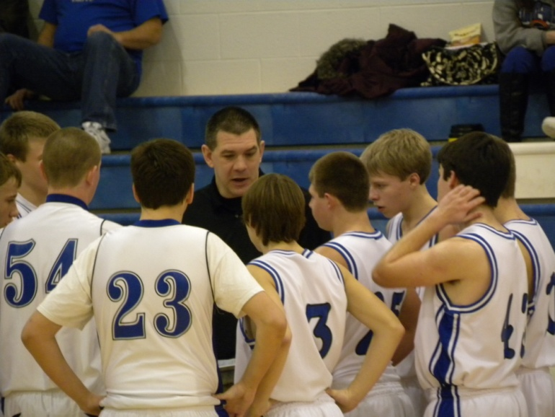

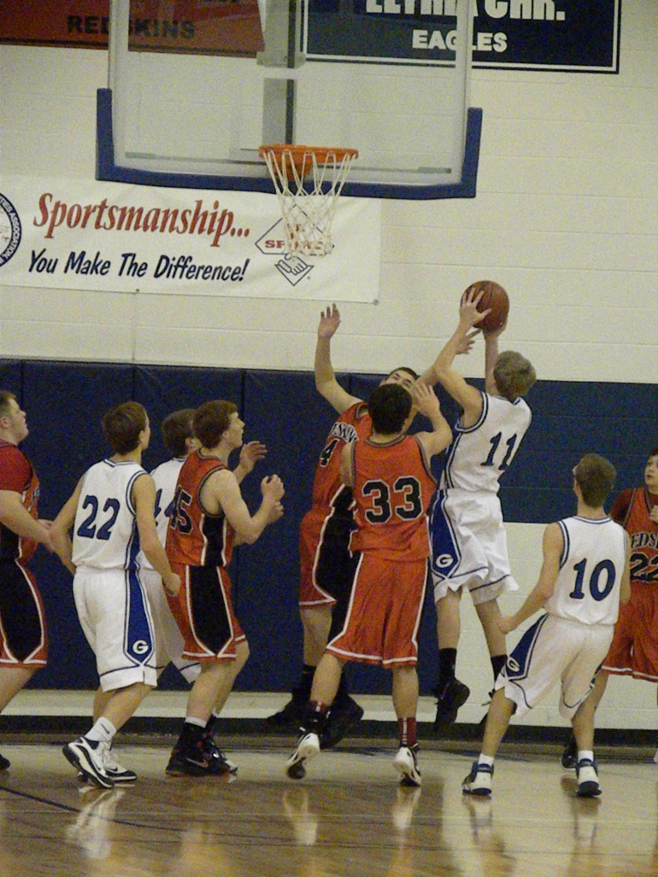

***Inside this Edition:***

*Sports Updates*

*Movie review by THE Bruce Benjamin*

*News from the “Friend”*

*Updated Brag Book*

*Reece Wear*

*Schroeder Shares*

CLUB UPDATES FOR FEBRUARY

FFA- National FFA Week is February 19th-25th. Kicking off with the FFA/FCCLA Lock-in Sunday and going through a community pancake feed on Saturday.

13-14- Orange Crush Sales

16- District Food Science, Poultry, and Ag Business Management

*Work Nights are on Mondays, time varies so please check the announcements

FCCLA- National FCCLA week is this week! Look in the Halls for interesting facts and listen to the announcements to enter yourself into a drawing over FCCLA trivia!

Stuco- Tuesday Spirit Day: Class Colors Wednesday: Favorite Sports Team Thursday: Nerd Day, and Friday: STOMP Day!!

--Homecoming dance this Friday!

[Huskies knock down the birds in OT]

In Tuesday’s league contest, the Lady Bluebirds almost pulled out a victory against the White City Huskies. By a final score of 48-46, the ladies lost in overtime in what may be considered their most exciting home game of the year. Jessica Harvey raked in 16 points and Johanna Hoffman, THE LEFTY, chipped in 10 points! Ali Buller pulled in an awesome 11 rebounds! If you are a Bluebird fan, this was not a game to miss, as the girls looked calm and collected toward the end of the fourth quarter, where a junior-led lineup included Harvey, Hoffman, Buller, and Alex Hiebert. Senior Aimee Flaming was also in the game when the game was on the line. Although the game turned out an L, the girls that were in the game in the clutch moments should be able to use this game as motivation for the rest of the season! (continued on page. 15)



***Poem Corner***

**Taking a walk with you**

Taking a walk in the summer with you

Is the best thing I could ever do.

We hold hands along the seashore,

The low tide splashing our bare feet.

The sun is setting in the west,

Setting off your golden highlights,

Making you look more beautiful than ever.

As I see this, I think to myself,

“How could I ever find someone I love more?”

**What a World**

What happened to this world?

What happened to innocence, decency, and full integrity?

I don’t want to be how people tell me to be.

I want to be what He called me to be.

There is a thing called purity,

That people don’t seem to know what it is anymore.

***Gossip on the Grey***

*The Grey* is a suspense-thrilling film starred by Liam Neeson, plotting man vs. wilderness in the third consecutive January film starring Neeson in the past three years. If you wanted this movie to be reckless, nonsense fighting with wolves then you will leave disappointed. But if you come into the film with an open mind, I guarantee you will not leave disappointed. Liam Neeson is pitted in a plane crash from Alaska that leaves him and six other survivors to survive in the Alaskan wilderness. Against all odds, the survivors face challenges with survival and claustrophobia. Killing wolves for food is just a small part of the whole story. As Neeson’s crew is killed off one-by-one by the pack of wolves, Neeson struggles with the inner fight of survival vs. giving up. (continued pg. 11)

*Boys Busy with Burrton Tourney*

The Goessel Bluebirds varsity guys’ basketball team traveled to Burrton on January 16 for the open of the Burrton Tournament. Goessel has been a regular competitor at this tournament since its start in 1979. Goessel came into the tournament with the 5th seed based on schedule record out of eight teams. The Bluebirds would play the 4th seed in the tournament, which turned out to be the Burrton Chargers. The two teams had met earlier in the season, with the Chargers coming out on top. After coming out of the gates with a low scoring first quarter, the Bluebirds scored 16 in the second to close the gap, with the score at 25-23. Goessel didn’t lose their step after halftime, scoring 11 to Burrton’s 10 in the third quarter. The fourth quarter was unfortunately a different story. The shots just wouldn’t fall, and the Bluebirds lost with a final score of 51-43. Foul trouble was a big issue for the Bluebirds, who had three of the starters end the game with either three or four fouls. Braden Unruh and Davis Cook led the team in points, with 13 and 11 respectively.

The Bluebirds came back to Burrton on Thursday to play the Cougars of Central Christian. They were another team that the Bluebirds played earlier in the season. The game was well fought from beginning to end, with the final score ending at 42-40 in favor of the Bluebirds. Some might say it was entirely too close, but a win is a win, and in a tournament that’s all that matters. (continued pg. 11)

**Battle at Berean Ends on a High Note- Written by Bruce Benjamin**

On January 23rd the girls basketball team started bracket play in the Berean Invite. Their first opponent was Word of Life High School located in Wichita, KS. After being way down after the first quarter, nothing could seem to go right for the Lady Bluebirds. The lone bright spot for the Lady Bluebirds was Jessica Harvey, who scored 10 points on 75% field goal shooting and 4-of-5 from the free throw line. But, she also had 9 turnovers and 3 fouls. The Lady Bluebirds lost this contest 66-29.

Looking to rebound from their last effort, the basketball team took on Douglass three days later. The Lady Bluebirds started off strong, playing a very good first quarter. But as time drug on, they could not compete with Douglass and ended up losing 35-21. Johanna Hoffman scored 8 points in the contest and Aimee Flaming contributed two assists and two steals, with only one foul.

Playing for the 7th place game the following Saturday, the Lady Bluebirds stunned Bluestem 52-43 for their third win of the season. Harvey led scoring with 18 points, Hoffman with 12, and Ali Buller dropped in 8 points for the Bluebirds. Good job Lady Bluebirds!



The Scoop on Schroeder

A product from our own system Tyler Schroeder has returned to become a business teacher, and I sat down and asked him about his life. Mr. Schroeder once roamed these halls and played High School sports like all of us. We all have our favorite teachers, and back when Mr. Schroeder was here his favorite teacher was one we still have today, and that is Mr. S-T. Mr. Schroeder said that he liked him because he found lots of ways and activities to get them moving in class.

In High School we all play our sports, and Mr. Schroeder was quite the athlete, he played Football, basketball and track. throughout High School you always need to think about what field/ profession you are going to be, and Mr. Schroeder was thinking in High School that he was going to be and he was thinking somewhere along the lines of a “Police Officer” or a “Lawyer.”

Next thing in Mr. Schroeder’s list was going to College and that’s when he decided to become a teacher, he went to Bethel College and had to think long and hard about it. In college he played just about the same amount of sports, except basketball. He threw shot-put and threw discus, he was a STRONG man, he threw a 7.4 lb discus 121.31 feet, was his personal best in college, and he threw a 16 lb shot-put 50.84 feet. I asked Mr. Schroeder why he wanted to play these sports, and he said he “enjoyed them, and because he got to hang out with his friends and get better both individually, and as a team, and it was always a challenge.”

Mr. Schroeder is currently the Head football coach at GHS, and he wants to be a coach because, he likes coaching in general, because it is a challenge with strategy, and that because there is always something to learn, and last because he gets to be involved in a game that he loves.

I asked Mr. Schroeder why he came back to Goessel, instead of going to a different school, and he said, “Because I have great pride here, I want to contribute to Goessel, and give something back to something that was so good to me.”\

As a fellow student I do kind of wonder what teachers do when not teaching or coaching and I asked what Mr. Schroeder did, and he says that his #1favorite thing to do while at home is to read, and then the #2 thing is to exercise.

I asked Mr. Schroeder the following questions about High School students:

**Students are:** *Usually Surprising*

**Advice to High School students:** *Stay active, and always be focused on the task at hand.*

*Written by Connor Davis*



Scholar’s Bowl Showdown at Goessel

The regular season for Scholar’s bowl has ended with the conclusion of the Goessel Tournament. Goessel had four teams compete in the meet. Two of the teams finished with a record of 3-2, one team 2-3, and the final team 1-4. All of the teams were divided up evenly according to abilities making all of the teams almost even. Going up against all of the stacked teams from all of the surrounding schools made the tournament difficult so in comparison Goessel competed well having divided teams. Congratulations on a great year for both Varsity and JV and good luck to the six competitors, Alex Schmidt, Stephan Goertzen, Braden Unruh, Jeff Hall, Johanna Hoffman, and Ben Wiens, who will be representing Goessel at the Regional meet on February 2. (see results pg 14.)

Written by Reece Hiebert

●●●

**Humor from Gems**

A new couple of lovers are having a conversation.

Male : I will go as fast as I can, for our future...

Female : Do you want to go to state court with me?

Male : Certainly! I have been waiting for that word!

Female : Will you break up with me?

Male : No way!

Female : If I anger you, will you try to reconcile me?

Male : For you, I will do it in any way.

Female : Will you hurt me?

Male : I would kill myself if I have done that.

Female : Kiss me...

After married 10 years, read from the bottom.

●●●

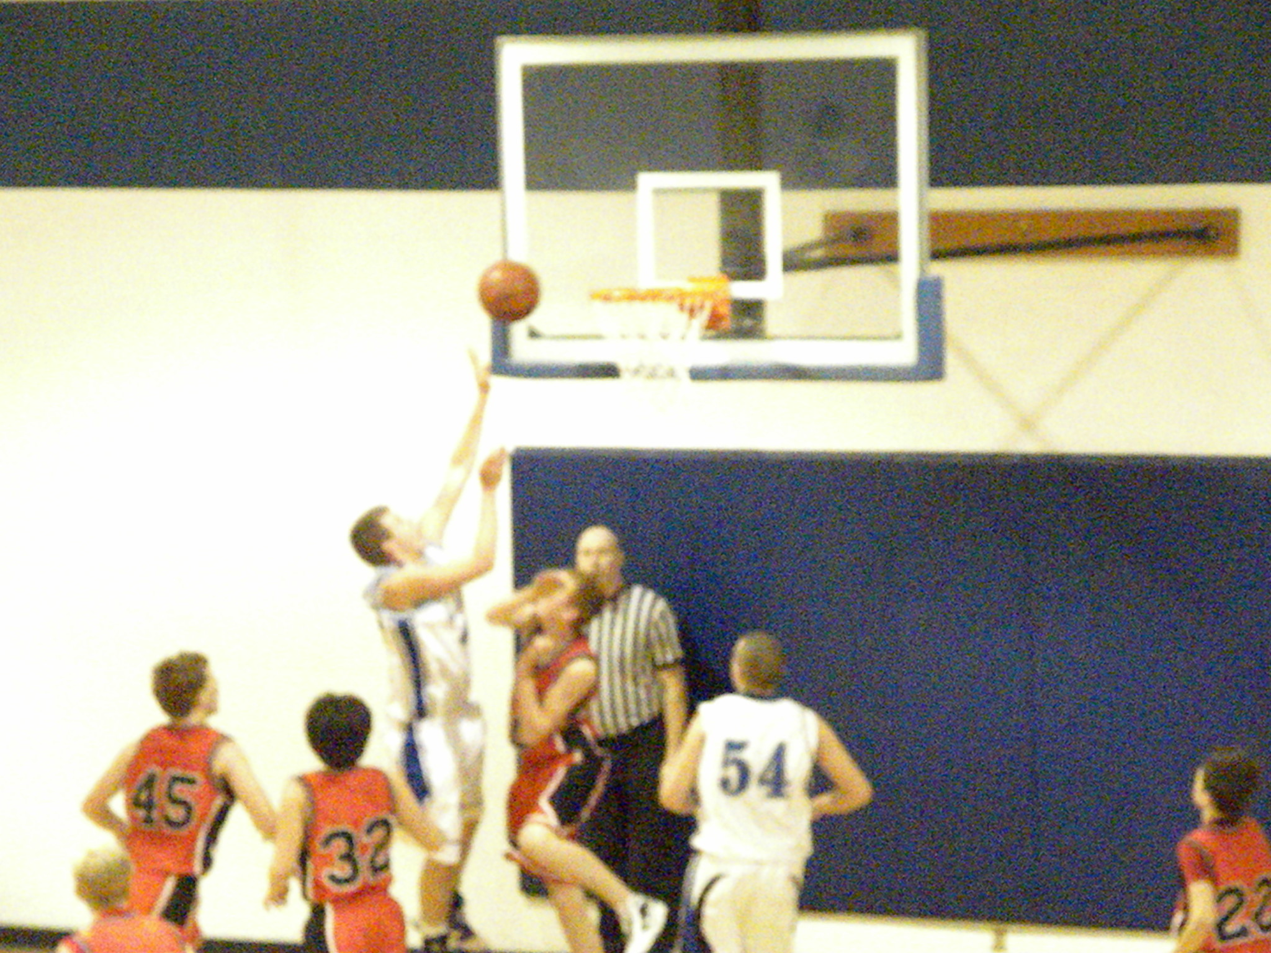

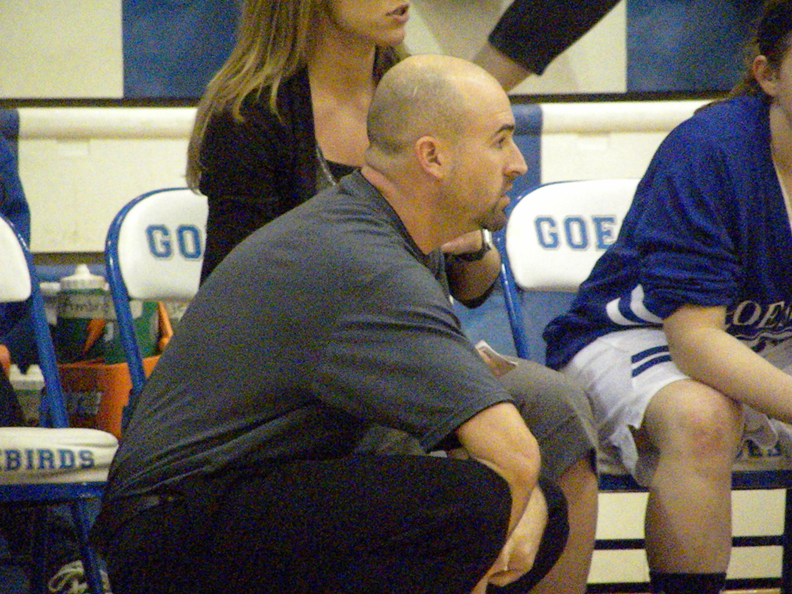

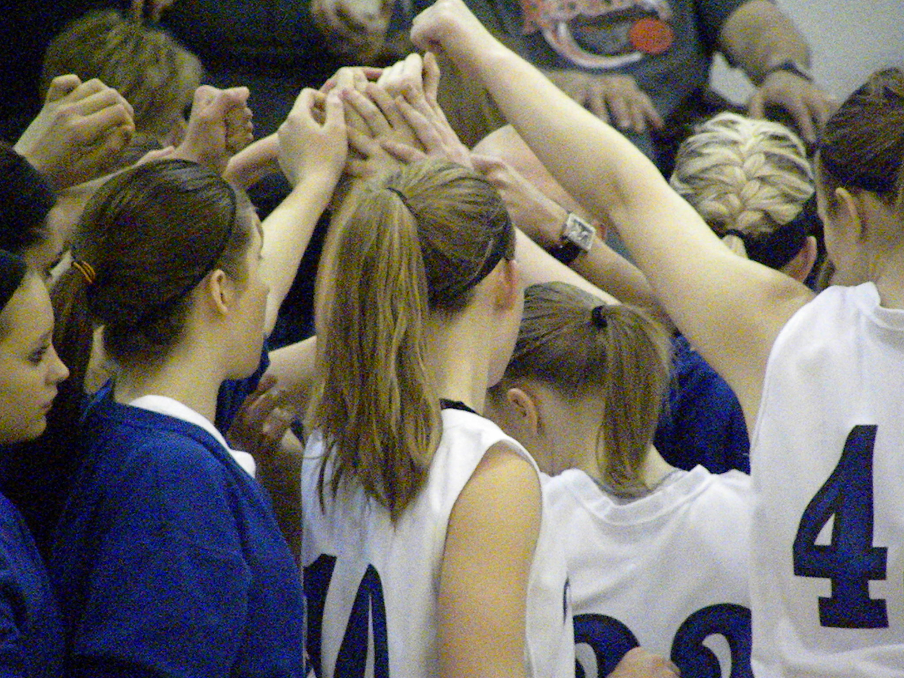

*Big Fight with Little River….*

On Tuesday night, the Little River Redskins beat the Goessel Bluebirds 43-33. The game came down to the wire with the Bluebirds being down 6 with 1:30 left to play, but fouls and quick press breaks broke the lead open to 10 and the Bluebirds could not come back. On a night where there seemed to be a lid over the basket for the Bluebirds, Braden Unruh lead the way with 13 points and Davis Cook scored 10. As a team, the Bluebirds could just not find their shot, going a combined 14-for-41 for field goals. The Bluebirds were only 2-for-7 from three point land. Trey Schmidt led the team with 2 assists. Even though the Bluebirds only had 4 assists for the game, as a team they had 3 blocks and 11 steals! Turns out the game ended up with an L, this game should pull the team together and be a turning point for the rest of the season. You guys have the whole communities’ support, and good luck to the men’s basketball team with the rest of the season!

A lack luster varsity game followed the impressive contest that the JV squad put together earning a win 51-34. They were the only team of the night to beat Little River. Ben Weins paved the way to the W with 16 points, and Nathan Czarnowsky had a team-high 6 rebounds. The boys came off a winning weekend at the Goessel Bluebird JV Tournament, where they were crowned champs for the ninth straight time, out of the nine years the tournament has taken place.

The C team lost a heartbreaker 45-34. Lawton Makovec led the team with 15 points, wow! Connor Davis led the team with 12 rebounds. C team, also had a tournament last weekend in Centre, which did not prove to add any tallies in the W column for the team. The team looks to turn around their luck this Friday at Centre. (continued page 9)

Big battle with Little River continued..

The Girls varsity squad couldn’t get everything lined up Tuesday the 31st, losing to Little River 49-19. No stranger to the game, point guard Jessica Harvey led the team in scoring with 12 of the 19 Bluebird points. Johanna Hoffman led the team in the game with four rebounds. Harvey also contributed 3 steals and 2 assists. No charges were drawn by the Bluebirds in the game. The Lady Bluebirds are in action again Friday the 3rd at Centre.

The Girls JV team lost a toughie 14-9. Erin Brubaker and Sam Jarvis both had 4 points to lead the team. Brubaker and Makayla King led the team with 2 rebounds each. The girls will also be traveling to Centre to take on the Cougars with the rest of the squads. Best of luck to the Bluebirds!

Written by the one and only Bruce Benjamin

*Valentines*

You may not know very many things about Valentine’s Day, so I am doing an article about different things about Valentine’s Day. I also found out there are different reasons Valentine’s Day is celebrated. One of the stories told is about a guy named St. Valentine. He was martyred for refusing to give up Christianity and died on February 14. Legend also says that St. Valentine left a farewell note for the jailer's daughter, who had become his friend, and signed it "From Your Valentine". One interesting thing I found about it, is that 141,000,000 Valentine’s Day cards are exchanged annually, and it is the 2nd most popular card giving occasion. Over 50% of all Valentine's Day cards are purchased in the six days before Valentine’s day, making it a procrastinator's favorite holiday.

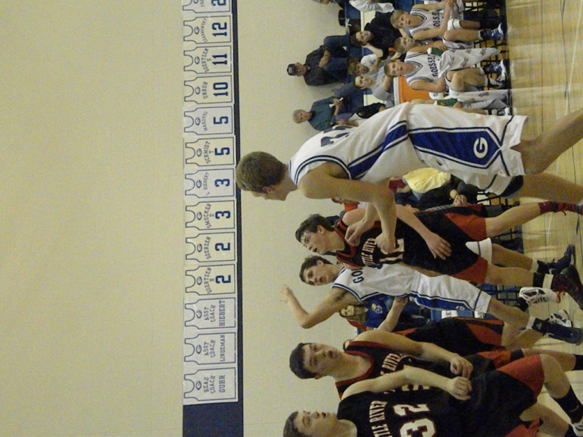 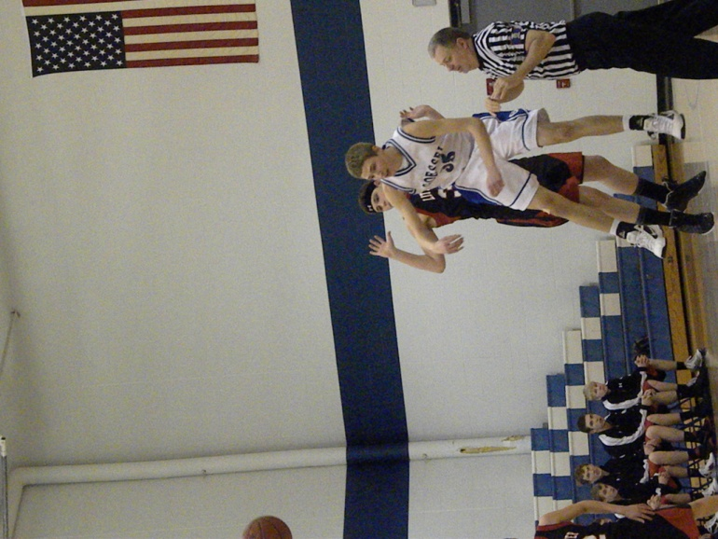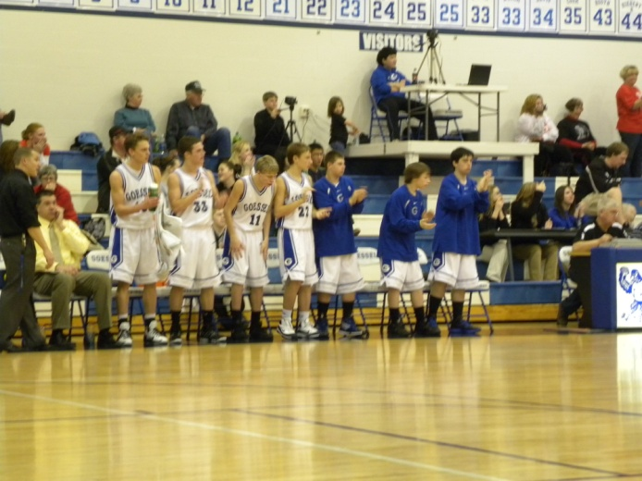

**Last Bat-compiled by Connor**

Braden

1. What are your future happenings***? “I would really like to graduate High School! I plan on going to college next year at a undecided location.”***
2. Freshmen mean what to you? ***“Freshmen are the future to our High School.”***
3. Favorite time to play Basketball***? “My favorite times to play are in free time or when friends are around”***
4. Why do you like basketball? “***It is a good pastime, and stress reliever”***
5. What is the best thing about being a senior? ***“Everything!”***
6. Favorite numbers? ***“8675309”***
7. If you could wish one thing to happen in your life right now it would be? “***An unlimited amount of butter-flake rolls”***
8. Favorite College basketball player? ***“Thomas Robinson”***
9. NBA player? ***“Blake Griffin”***
10. Favorite musical artist? ***“Yellowcard”***
11. Most attractive celebrity? ***“Sara Bareilles”***

**Bruce Review continued..**

As Neeson’s character progresses throughout the film, the ending is where you can see his transformation the most. Once he is the last one living, he finally reaches the tree-line where they assumed there would be civilization. When he approaches the trees, he learns that throughout the whole movie, he was accidently leading the gang into the heart of the wolf den. As Neeson readies himself for one final fight with the Alpha wolf, he finally realizes his full potential and character. If you want to see if Neeson survives, you will have to watch the movie yourself. (continued pg. 18)

Burrton Invite Continued

The final game pitted a rematch between the Bluebirds and the Teutons of Inman for a battle of 5th place in the tournament. After a very long week with travels and school, the Bluebirds couldn’t ever seem to catch that spark a team needs to overtake another. After four well fought quarters, the game ended at 55-37 in favor of Inman. Braden Unruh, who finished the game with 15 points, was elected to the All-Tournament team for the second year in a row. While the results of the tournament may have not been what many were hoping for or expecting, the games served as a valuable learning experience for the road ahead.

By: Josh Booth

*Thai School vs. Goessel – written by Gems*

In Goessel, an average school day start at 8:00 A.M. and end at 3:30 P.M. However, school in Thailand start around 8:30 A.M. but we have to be in school before 8:00 A.M. and school end at 4:00 P.M. except for special class called “King” or “Gifted” which are end at 5:10 P.M.

You cannot choose your class for the whole day in Thai school (Fixed schedule). Thai students have to study Physic, Biology, English, Thai, and Math per one day at least 3-4 days a week at 9th grade or above. Schools in Thailand usually have more than 1000 students in one school.

Thai schools have long lunch time, at least 1 hour. There are many stores in some school.

Thai students need to have a short hair and wear uniforms. Many students try to avoid hair checking by skip it sometimes. (continued pg. 16)

The following are current basketball stats taken on February 13th. Congrats to the Bluebirds that made it in the Brag Book!

Boys Girls Frosh/JV Boys JV Girls

Points Per Game: Braden: 13.5 Jess: 7.3 Ben: 10.1 E.B: 3.5

Charity Stripe Percentage: Davis: 76 Ali: 81 Connor: 80 Caroline: 50

Pulling the Most Rebounds: Davis:112 Jess: 83 Brian: 88 Sam: 34

Tossing the Rock (assists): Trey: 35 Jess: 36 Ben: 80/Dan 80 Makayla: 5

**KMEA Update**

--State KMEA Choir singers: Drake, Tyler, Jeff, and Josh. Way to go singers!! These young gents will be showcasing their talents February 23-25th at State KMEA. This a recognition for 1-4 A high schools, so a large achievement for our very own Goessel singers.

--State KMEA Band: Braden, Reece, and Grant. Nice Job musicians. This is also a 1-4A recognition for these musicians. Reece received the highest honor and is the first chair for bass clarinet. Braden is the second chair as a trumpet, and Grant is the sixth chair also as a trumpet. They will be playing their hearts out February 23-25th in Wichita in the State KMEA Orchestra.

-- Congrats to the music department and their achievements!!

FCCLA puts a new meaning to the word GOLD!

Mrs. Bergin’s FCCLA students are currently preparing for STAR Events and planning out activities for FCCLA week.  STAR Events stands for: Students Taking Action with Recognition.

There are 12 students participating in a total of 9 STAR Events at the district level this year.  They will compete in Marion on February 1st to see if their project goes on to the State Level.

(results on page 17.)

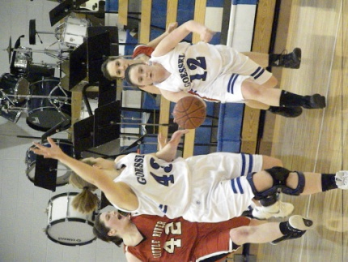

*Last Bat- compiled by Connor Davis*

Samantha Jarvis

1. **What college do you plan on going to?** *“Right now I haven’t decided, but I am looking at maybe Sterling, Bethel, K-State, or Southwestern College.”*
2. **What happened to your knee? “***Well I injured it twice, the first time when I was playing the limbo in PE class my freshman year- in which I broke my knee cap and tore a bunch of cartilage. The 2nd time was my junior year after leaf raking, I was in the gym and landed on a basketball that was under a goal after a layup- then I tore the inside reticulum in my knee, which I had to have reconstructed.”*
3. **What are freshman girls like?** *“Just like any other people I guess, they just seem to have more fun and be sillier than the seniors most times.”*
4. **Favorite sport?** *“Softball, but since Goessel doesn’t have it, basketball I guess.”*
5. **Favorite song/ artist?** *“My favorite song right now is “Suddenly I see” by KT Tunstall*
6. **What do you think about art?** *“It’s the easiest way to express myself, and be accepted”*
7. **Art means what to you?** *“It means an escape from my life.”*
8. **Favorite thing to do on the weekend?** *“Draw/paint on my walls while singing along to the music on my computer.”*
9. **Nike or Adidas?** *“Adidas”*
10. **Most awesome achievement?** *“Having courage to stand up for people (one event in particular)”*

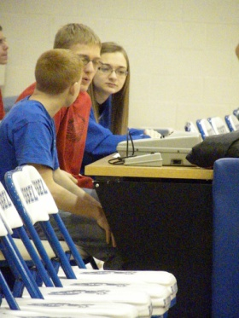

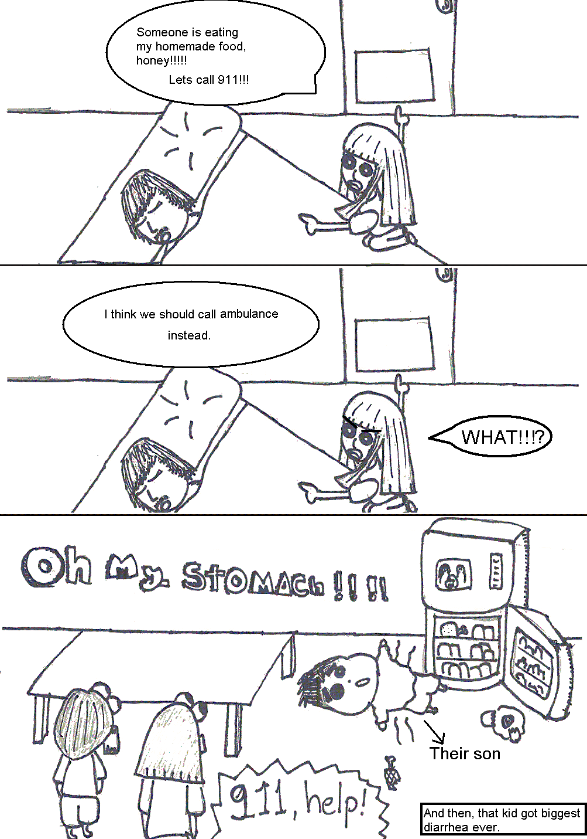

**Thai School vs. Goessel continued…**

Personally, I enjoy both of these schools. I like Goessel because there are air conditioners everywhere. There are smaller schools so I don’t have to walk as much. I also like Thai school in lunch time which is longer, more gym time for playing sports during lunch time. Anyway if Thai school is small like Goessel, it will be the most crowded place in the world!

Excerpts from 1954—how times have changed

Dear Santa,

The thing I want for Christmas, that you could give me, is a pair of black shoes and a purse to match.

The last thing I want is a piece of mistletoe, for reasons best known to me and someone else.

Julia Dirksen

Dear Santa,

One thing I need very badly is a brand new Henry J. or Areo Willys School bus so I can take the team (I don’t mean your team of reindeer but the basketball team,) to all of their ball games.

I would also like a year’s supply of sleeping pills, because I always have so much trouble falling asleep at night. I count my sheep the number of times. I’ve been told off, the days till school lets out, and everything but nothing helps. If you can, I’d like the kind of pills they advertize over Del-Rio, Texas.

Esther Schmidt

Gems

**Review by Bruce Benjamin continued…**

**Pros:**

-Great visuals!  
-Film submerges you into viewing it   
-Neeson’s brilliant acting   
-Wolves look very real; suspenseful **Cons:**

-Film is 2 hours long

-Easy to lose track of time

-Sometimes people in the movie don’t pay attention



Rating: 9/10 Bruce’s Seal of Approval

**Spiffy Country Wear**

This is Reece bringing you your monthly fashion report. Thanks to all of the fans of ReeceWear for making this fashion column the most popular article in the Bluebird! If there is one thing that I love more than my fashion it is cows. So why not combine the two for cowboy ReeceWear. First off, cowboy boots are a must have fashion statement! They are more durable than tennis shoes in my opinion and since I am writing the article my opinion is the most important. Boots can be used for any occasion and always look spiffy. If you can find a pair of boots that is another color other than brown or black like green for example that would be best (because my favorite color is green). But boots are not cool at all unless you have the right jeans to go with them. For jeans it is the same way as shorts for guys, there is such a thing as to short. Every good pair of boots needs a nice pair of jeans to go with it. The right pair of jeans has to be long enough to cover the ankles at least otherwise they are getting a little short. Specific brand name doesn’t matter but if you can find a pair with some cool stitching that makes for better ReeceWear. Another large factor for ReeceWear is NO SKINNY jeans! Girls don’t like guys that have jeans stuck to their thighs. (Continued next page)

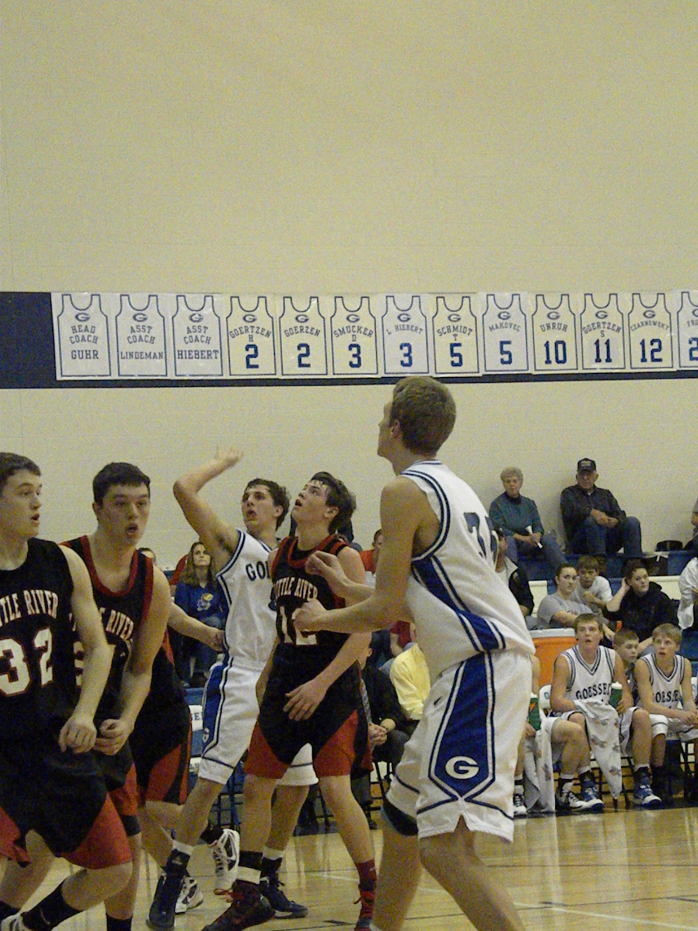

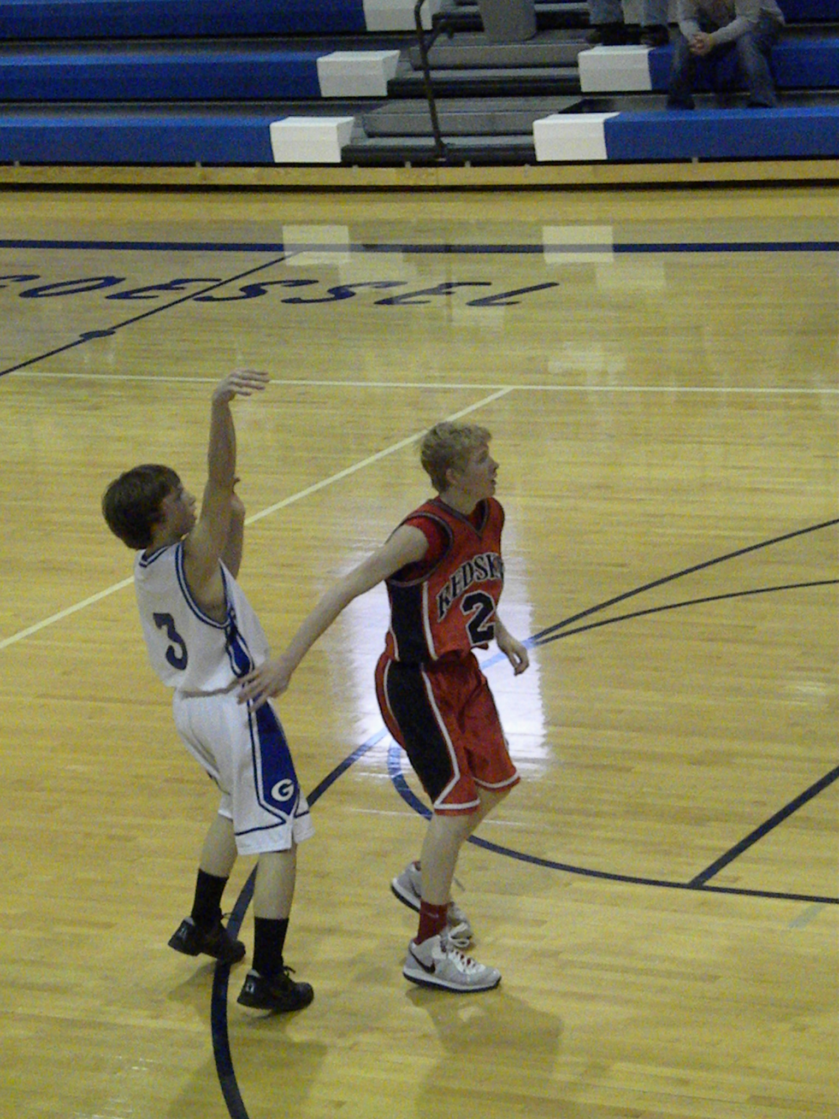

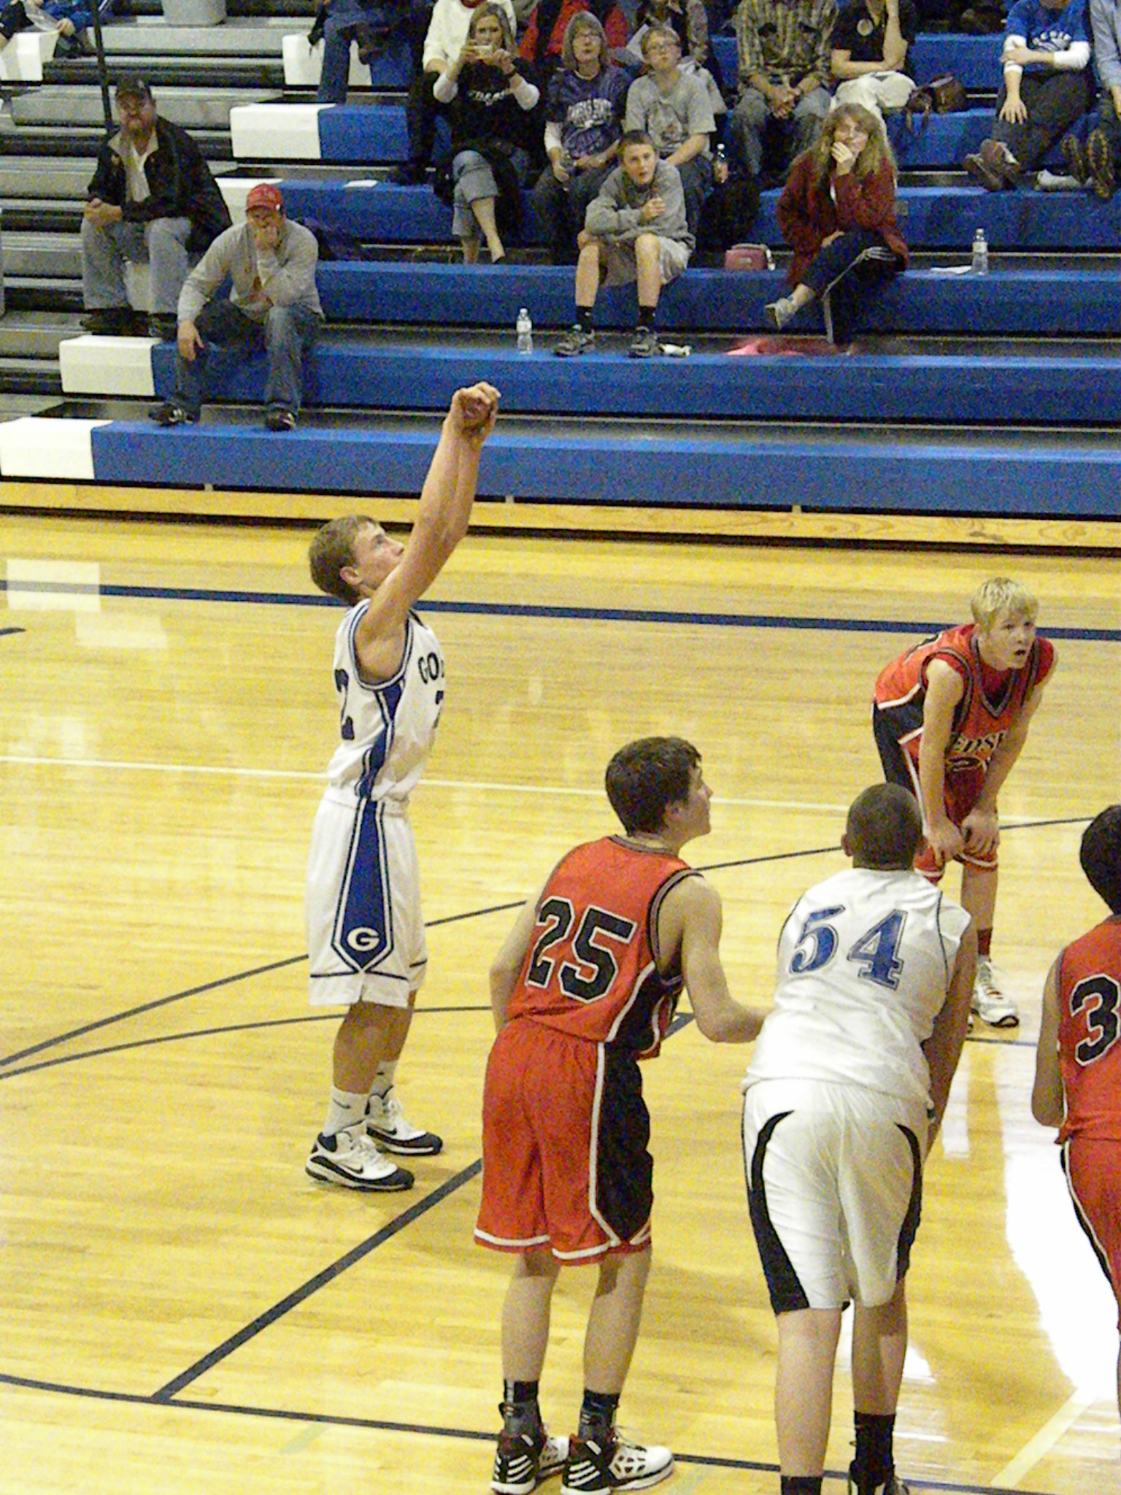

Last Bat- compiled by Connor---Nathan Burch

* Future happenings? ***“take the year off, and also work”***
* Favorite class? ***“Ag Mech”***
* Favorite activity? ***“Hunting”***
* Favorite time to weld? ***“Morning”***
* What do you like to weld? ***“Bout Anything”***
* Camo means what to you? “***Favorite color, hunting”***
* What do you want to go to college for? “***Weld for someone, with ag”***
* What college? ***“KSU”***
* Being a senior is? ***“Awesome”***
* What is your favorite hunting time? ***“Morning, Late afternoon”***

FCCLA Results continued…

Alex Hiebert is making a new dress out of an old tank top and an old formal dress for the event, "Recycle and Redesign." GOT GOLD!!!

 Kara Schmucker taught a lesson about weather to the Kindergarten class for the event, "Teach and Train." Got GOLD!!!

 Rachel Abbas is creating a new recipe for a portable pita burger for the event, "Food Innovations."

 April Moon, Chelsea Stika, and Tara Race conducted a third grade fitness class for the event, "Focus on Children." All three dominated but didn’t get gold, keep fighting ladies!

 Darren Hammond is giving a presentation about kitchen safety for the event, "Illustrated Talk." Did well and compete hard.

 Nate Bray is teaching a lesson about animal behavior to the seventh grade science class for the event, "Teach and Train." Got GOLD!!!

 Nicki Bartel is creating a portfolio about becoming an accountant for the event, "Career Investigation." GOT GOLD!!!

 Tia Goertzen and Paige Booton are creating a scrapbook of Goessel FCCLA's achievements this year for the event, "Chapter Showcase Manual." GOT GOLD!!!

 Jason Meysing did research about pop and its side effects for the event, "Illustrated Talk." Put up a huge fight! But didn’t quite get gold.

* Compiled by Connor Davis

Enough jibber-jabber, let's get down to business. I opened up the interview with a very obvious question, "What made you think of creating this mysterious persona?" He responded with "I wanted to make the school a slightly more interesting place. My goal is to promote school spirit and unite the student body. Although it may not be obvious how, I feel I have accomplished this to some degree. However, I have not reached my end goal."

I learned that he has had some close calls while in the act of friendliness. While decorating for Christmas he was almost spotted by Dr. Fast, and when he filled the "Justin Dean Coup Room of Studies" with balloons Papa Wes was working in his classroom. When asked about note preparation he informed me that the notes are usually done the night before delivery, but the people receiving the notes are often a spur of the moment decision. He also told me he has not created the next round of messages yet, but there is possibly an identity revealing event in the future.

When asked if being "The Friend" is fun, he had this to say: "It is fun but extremely time consuming and very expensive. I particularly enjoy seeing people's reactions. I hear a lot of compliments and I also hear some of my closest friends dissing me to my face without knowing it. It is interesting to hear people's candid opinions."

I learned that he is a one man operation with no one knowing his true identity here in Goessel. However, he has used students with the purpose of delivering other notes to other students as to avoid the cameras. Obviously he is a very clever individual and he would love to hear any of your feedback on his shenanigans and how you view him. All you have to do is go on Facebook and "Friend The Friend."

ReeceWear Continued…

As I have said in the last article I don’t know that much, if anything about girls fashion and what is cool. I am just here for the guys’ advice and that is struggle enough. So just a recap, the more extravagant stitching there is the better, colored boots are cool and give your legs room to breathe in your jeans. This has been Reece with your update on ReeceWear.

Unveiling Elbiata

In the hallways of Goessel, there is a group like none other. These are twenty gifted souls who come together with the purpose of creating beautiful music with only their voices to offer. They have been known to travel from place to place, spreading the gift of happiness to the ears of the community, leaving many to believe they just had been blessed by the voices of angels. They go by many names, including “The Chosen Ones,” “El Diablo’s,” and “Those Guys Dressed in the Funny Looking Tuxedos,” but most commonly known as “Elbiata.”

Elbiata has been a singing group at Goessel since the beginning of time, or at least since the 90’s. These singers are top-notch, and many have been recognized as the best in the state. This year is no different, as Jeffrey Hall, Tyler Schulz, Josh Booth, and Drake Sterk have been selected to the KMEA All-State Choir. When 20 talented individuals come together in one group, you can imagine that they blow away everybody else. Elbiata has built a reputation in the area as the premier high school choral group, being recognized with numerous awards and performing at prestigious contests and events.

Elbiata has made it a tradition to perform a select number of songs at the Goessel area churches and wherever else the senior singers go to. This year Elbiata has put a lot of miles under their feet since there are currently 11 seniors, and many go to different churches. Including the Goessel area churches, Elbiata has performed in McPherson, Hillsboro, and Wichita. All the performances have been great in their own ways, and as a veteran member of four years myself, I think it is awesome to experience how other people worship and get a feel for other church affiliations.

With any organization, there is always a need for money for trips and supplies. Elbiata doesn’t hold a bake sale or car wash to raise money though. They perform three romantic songs for other peoples’ loved ones and call it “Singing Valentines.” People donate money to the program and we are provided the names of the targets and when and where they are. Think of us as musical assassins. It is always a good time for the singers as they get out of school for the sole purpose of embarrassing their customers. At least that’s why I enjoy it. Anywhere with oxygen is fair game for the Elbiata singers to travel to. Hospitals, tire shops, schools, nursing homes, airport hangars, and restaurants are just some of the places they have sung at. Unfortunately this year’s Singing Valentines comes after writing this article, but it will no doubt be another fun time of embarrassing those who other people put on our hit list.

Guys win thriller off Huskies late mishaps

On the same night, the guys also had their most exciting game of the season. The Bluebirds won the game 31-29 with late game free throws from Braden Unruh and free throw misses from the Huskies. Leading scorer from the game was Unruh with 19 points. Unruh had 6 rebounds to lead the team, but a good game by Peter Voth also hauled in 6 boards. Seeing the Bluebirds pull out the win over White City was great, as White City only had one loss on the season. Goessel is now on path to finish 3rd in the Wheat State League, pending the game with Peabody. Good luck to the men’s Bluebird team!